Ultrasound Sensitivity Validation Procedure
The following procedure Illustrates how to perform a QA validation on of the Ultrasonic Testing Devices. This is different from the Calibration which is recommended annually on each unit. The Sensitivity Validation Procedure is a method through which the user can insure that the Ultrasonic Unit, Modules and Headphones are in proper working order. Use the Sensitivity Validation Log to enter the readings this will insure that the user can quickly identify a failing unit or module. This procedure can be used to check the validity of Ultrasonic Units between Calibrations and in no means, is it to replace the recommended Calibration of any Ultrasonic Unit. A drop-in decibel of 1-5 dB’s is usually related to Tone Generators not being fully charged. A drop between 6-10 dB’s can usually be attributed to equipment damage. The user will be able to determine this through the following steps:
- If only one item shows a decrease, then it is the module that will need to be repaired.
- If all modules show a decrease, then it’s the Ultrasonic Unit itself that’s in error.
The QA/Sensitivity Validation procedure meets the intent of ASTM Standard E 1002-11 and should be performed before each use. The following items will be required to perform the Sensitivity Validation Procedure.
Equipment List:
- Ultrasonic Unit
- Head Phones
- Tone Generator
- Contact Module
- Airborne Module
- Parabolic Dish
- Flex Probe
Procedural Steps:
- To begin, clear off a spot on a table or desk to perform the Sensitivity Validation Process
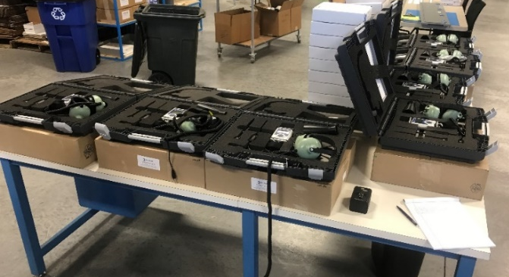
- Always turn on your Tone Generator to the Low Setting when preforming a Sensitivity Validation. Place the TG on its back side with the light facing up.
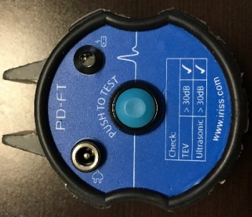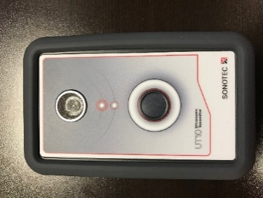
- Plug in the Headphones and place them on the table and keep them plugged in the entire time. This will verify the headphones are in working order.

- Power up the Ultrasonic Unit and ensure the Light and Max Reading are working.
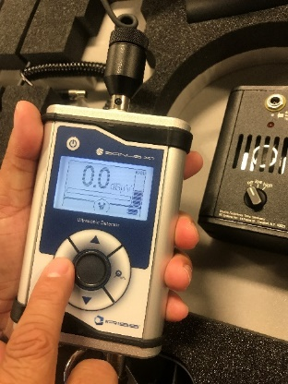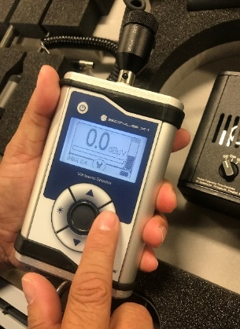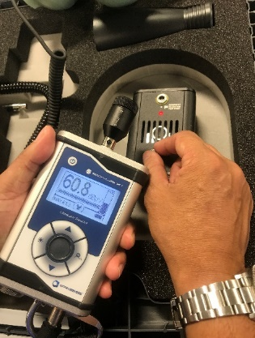
- Place the Contact Module in the front of the unit and touch it to the Sensitivity Validation Test Point and let the weight of the unit rest there with little movement.
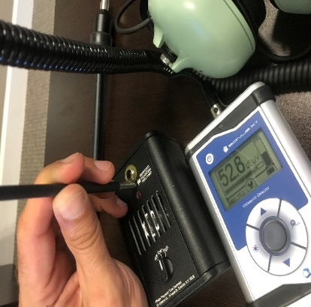
- Us the Max dB Value and Log that dB’s, and the Volume Level on the Sensitivity Log Sheet.
- Log the Ultrasonic Units Serial Number and Module serial number and results on the Log sheet.

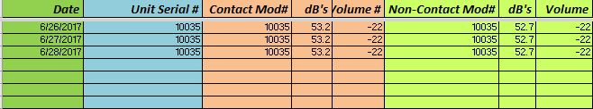
Replace the Contact Module with the Parabolic Dish or Flex probe and repeat the steps above to complete the QA/Sensitivity Validation Procedure. You will need to position both of these module’s one foot from the end of the module for this process.

Use this sheet to log your findings each day of class.
